Corrosion Growth Assessment Report

Enbridge Gas Inc (D)
NPS 10 Natural Gas Pipeline – 10DAW167
enniskillen valve site to 167 pool compressor

PROJECT NUMBER: 0-1001-18081
REVISION No.: 0
REVISION DATE: October 20, 2026

pREPARED by:
Author M. Razzak
QA J. Doyle
Approver M. Pattison

© ROSEN GROUP 2026
CONFIDENTIALITY AND COPYRIGHT
This report (including any enclosures, attachments and digital deliverables) (the “Report”) has been prepared for the exclusive use and benefit of the addressee(s) and solely for the purpose for which it is provided. Nothing in this Report should be considered a guarantee or warranty of the correctness or completeness of data or conclusions contained herein. Unless ROSEN provides express prior written consent, no part of this Report should be reproduced, distributed or otherwise communicated to any third party. ROSEN does not accept any liability if this Report is used for an alternative purpose from which it is intended, nor shall ROSEN have any liability to any third party in respect of this Report. ROSEN collects data using various physical principles. ROSEN processes this data in various ways to produce reports that include but are not limited to text, images, tables, listings, and graphs. The data processing ROSEN completes includes but is not limited to integration with other data, distance adaptation, noise filtering, interpolation, and calculations.

Prepared by

M. Razzak, Ph.D., P.Eng.
Checked by

J. Doyle, Integrity Specialist
Approved by

Martin Pattison
0 | October 20, 2026 | 25 | Review copy | M. Razzak | J. Doyle | Martin Pattison
Rev. | Date | Pages | Description | Prepared by | Checked by | Approved by

Executive Summary
The following section summarizes the results of a Corrosion Growth Assessment (CGApro service with AutoSCAN) for Enbridge Gas Ontario regarding the NPS 10 No. 167 Pool (10DAW167) natural gas pipeline, completed in accordance with the scope of work (‎Appendix A). The detailed results are provided in the accompanying Excel listing ('NPS 10 167 Pool (10DAW167)_CGApro_AutoSCAN_Listing_Rev0_2.xlsx'). The assessment methodologies and relevant industry references are detailed in the ROSEN Standard Methodology Document for Fitness for Purpose-- Assessment (FFP) and Corrosion Growth Assessment (CGA) services.

Corrosion Anomaly Results
- No external corrosion anomalies were classified as New. Of the 474 individual internal corrosion anomalies, 27 (5.7%) were classified as New, with reported depths of 10–15% wt.
- 49 of the 474 internal corrosion anomalies (10.3%) showed a depth change greater than 5% wt. Based on the results of the AutoSCAN analysis and signal comparison review, internal corrosion was considered likely active between inspections for the pipeline, particularly at log distances of 26, 823, 949, 1,380, 1,487 and 2,861 m.
- The 11 individual external corrosion anomalies comprise 10 Matched and 1 Matched (Reduced Accuracy). The maximum estimated matched CGR was 0.04 mm/year, associated with a 16% wt anomaly at log distance 2,575.358 m.
- Based on the CGApro results, the internal corrosion CGR segment is summarized below:
Segment ID | Start Distance (m) | End Distance (m) | Saved CGR (mm/year)
IC1 | Start of Line | End of Line | 0.044 mm/year
- The AutoSCAN comparison covers the 2016 and 2026 MFL-A/C ILIs, with a calculation interval of 9.80 years.
- 28 anomalies have calculated CGRs higher than the recommended segment CGR. These anomalies are considered outliers and are recommended to be grown at their respective growth rates, as summarized below: Verification required: confirm the outlier selection; 30 Listing CGRs exceed their listed recommended rates.
AutoSCAN Comment | Log Distance  (m) | Joint No. | Orientation  (hh:mm) | Depth  (% wt) | Outlier CGR  (mm/year)
New | 3518.963 - 3522.139 | ILI.GW.386 | Various | 10-15 | 0.13-0.19

The above CGRs were based on data available at the time of the study and are recommended for use in future integrity management studies. If Enbridge Gas Ontario finds evidence that these CGRs are not representative, then they should be redefined on the basis of any additional data.
Non-Corrosion Metal Loss Anomaly Results
- 96 individual non-corrosion anomalies are included in the comparison listing: 91 Matched and 5 Matched (Reduced Accuracy).
Geometric Anomaly Results
- All 14 geometric anomalies reported by the 2026 ROSEN ILI were compared using a box-matching and signal-review process. Four have previous-inspection entries and were matched. Signal review against the 2016 ROSEN ILI showed matching profiles for the ten dents that were present but not reported.

Table of Contents
Executive Summary 3
Table of Contents 5
1 Pipeline Background 6
1.1 Pipeline Data 6
1.2 ILI Summary 6
1.3 ILI Findings 8
1.4 Summary of Repair Data 9
1.4.1 Re-Routes 9
1.4.2 ILI Identified Repairs 9
1.4.3 Client Supplied Repair Data 10
2 Data Review 11
2.1 Internal Corrosion 11
2.2 External Corrosion 11
2.3 Non-Corrosion Metal Loss 12
2.3.1 Pipe Mill Anomalies 12
2.3.2 Longitudinal Weld Anomalies 13
2.4 Geometric Anomalies 14
3 ILI Comparison 15
3.1 CGA^{pro} with AutoSCAN 15
3.2 Internal Corrosion 15
3.2.1 ILI Comparison: AutoSCAN 15
3.2.2 Recommended Corrosion Growth Rates 15
3.3 External Corrosion 15
3.3.1 ILI Comparison: AutoSCAN 15
3.3.2 Recommended Corrosion Growth Rates 18
3.4 Non-Corrosion Metal Loss 20
3.4.1 ILI Comparison: AutoSCAN 20
3.5 Geometric Anomalies 21
4 References 22
LEGAL DISCLAIMER 23
ENGINEERING BASIS, RESPONSIBILITY, AND LIMITATIONS 23
Appendix A Scope of Work 25
Appendix B Signal Comparisons 26

Pipeline Background
This section summarizes the pipeline details, in-line inspection (ILI) history and known repairs for the pipeline subject to assessment, in accordance with the agreed scope of work (‎Appendix A) [1]. Verification required: reconcile the contents and section numbering with the remaining headings.

Pipeline Data
Table 1: Pipeline Details [2]
ROSEN Line Reference | 10DAW167
Client Line Reference | NPS 10 No. 167 Pool
Nominal Diameter | NPS 10
Launcher | Enniskillen Valve Site
Receiver | 167 Pool Compressor
Inspected Length | 3.53 km
Pipe Type | Longitudinally Welded
Nominal Wall Thickness | 5.60 / 7.80 / 9.30 / 12.70 mm
Pipe Grade | API 5L X42
Product | Natural Gas
Maximum Operating Pressure (MOP) | 6,800 kPa
Construction Year | 1968

ILI Summary
The assessments are based on the ILI data for the pipeline [2] [3]; details are provided in Table 2.
Table 2: ILI Details
 | Recent ILI | Previous ILI
Vendor | ROSEN | ROSEN
Date | 2026 | 2016
Technology | RoCombo MFL-A/XT with Gyro  RoCorr MFL-C | RoCombo MFL-A/XT with Gyro & RoCorr MFL-C

Based on the quality statement for both ILIs [2] [3], the data were considered acceptable for use throughout the assessment. Table 3 summarizes the data quality statements for the tool technologies used in this assessment. For detailed information, please refer to the corresponding final inspection report [2] [3].
Table 3: Data Quality Summary
Run Date | ILI Tool | Status | Comment
April 7, 2026 | MFL-A/XT with Gyro | Accepted | The run was of acceptable quality with 100% data coverage. Average tool velocity was 1.82 m/s and maximum tool velocity was 3.90 m/s.
April 8, 2026 | MFL-C | Accepted | The run was of acceptable quality with full data coverage. Average tool velocity was 2.10 m/s and maximum tool velocity was 6.90 m/s.
June 20 / 29, 2016 | MFL-A/XT with Gyro & MFL-C | Accepted; speed excursions noted | The quality summary records 100% sensor coverage for both 2016 technologies.  Speed excursions and possible local data-quality degradation were identified for both runs.  The quality summary gives average velocities of 1.95 m/s for MFL-A/XT and 1.83 m/s for MFL-C; separate run tables contain differing values.  The quality summary gives average magnetizations of 24.86 kA/m for MFL-A/XT and 25.50 kA/m for MFL-C.

ILI Findings
A summary of the anomalies reported by the 2026 and 2016 ILIs is provided in Table 4.
Table 4: Summary of ILI Findings
Anomaly Type |  | 2026 ROSEN MFL-A/XT with Gyro  ROSEN MFL-C |  | 2016 ROSEN MFL-A/XT with Gyro & MFL-C
 |  | Number Reported | Maximum Reported Depth | Number Reported | Maximum Reported Depth
Corrosion (Internal and External) |  | 393 | 32% | 474 | Not established
Pipe Mill Anomaly |  | 9 | - | 52 | -
Longitudinal Weld Anomaly |  | 14 | - | 4 | -
Girth Weld Anomaly |  | 0 | - | 0 | -
Pipe Mill Anomaly  (with metal loss) |  | 116 | 19% | 325 | 22%
Longitudinal Weld Anomaly  (with metal loss) |  | 28 | 29% | 32 | Not established
Dent |  | 14 | 1.4% OD | 5 | Not established
Dent with Metal Loss |  | 0 | - | 0 | -
Dent with Grooving |  | 0 | - | 0 | -
Wrinkle |  | 0 | - | 0 | -
Ovality |  | 0 | - | 0 | -
Extra Metal |  | 0 | - | 0 | -
Total |  | 574 |  | 892
Notes | The 2026 Final Report [2] utilized combined reporting from both the RoCombo MFL-A/XT with Gyro and the RoCorr MFL-C run. The counts above reflect this combined reporting.
 | The accompanying ILI dataset contains 574 reported anomalies, compared with 577 in the inspection summary [2]. Differences occur in internal corrosion, external corrosion, sized pipe mill and sized longitudinal weld counts. These population differences require verification.
 | The current inspection applied 6t interaction criteria [2]; the previous inspection applied 3t by 3t criteria [3]. The counts above use the cluster membership recorded in the accompanying ILI dataset.
 | Unsized indications are included in the reported anomaly counts. A volumetric depth change was not established for these indications.
 | The anomaly counts above include clusters and single anomalies which are not part of clusters because they are not interacting. The counts do not include each individual anomaly which forms part of a cluster.

Summary of Repair Data
No repair data was available for this pipeline.

ILI Identified Repairs
Sleeve repair history was not available for this assessment.

Internal Corrosion
The 2026 ILI reported 383 internal corrosion anomalies, and the maximum reported depth is 32% wt at log distance of 747.680 m.
The distribution of the reported internal corrosion anomalies is shown in Figure 1, with respect to depth, orientation and pipeline elevation.
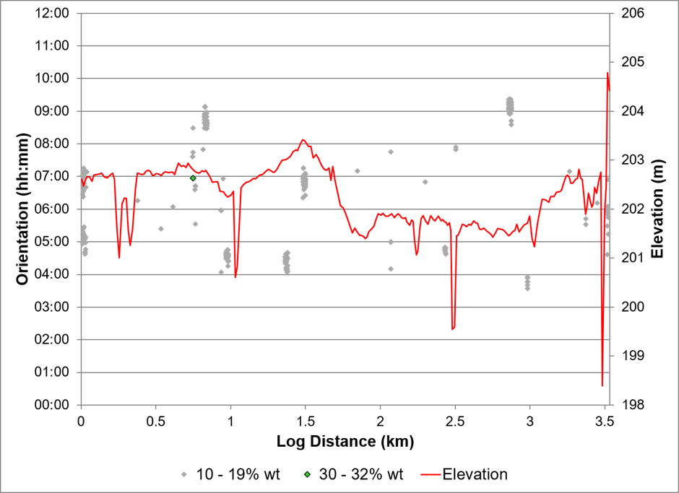
Figure 1: Internal Corrosion; Depth, Orientation & Elevation vs. Log Distance
The internal corrosions were concentrated at the 26, 823, 949, 1380, 1487 and 2861 m log-distance.
The internal corrosion anomalies detected by MFL-A/C were included in the ILI comparison stage, discussed in Section ‎3.3, to determine whether any change had occurred between inspections.

External Corrosion
The 2026 ILI dataset reported 10 external corrosion anomalies, and the maximum reported depth was 18% wt at log distance 3,075.300 m.

The distribution of reported external corrosion anomalies is shown in Figure 2, with respect to depth, orientation and pipeline elevation.

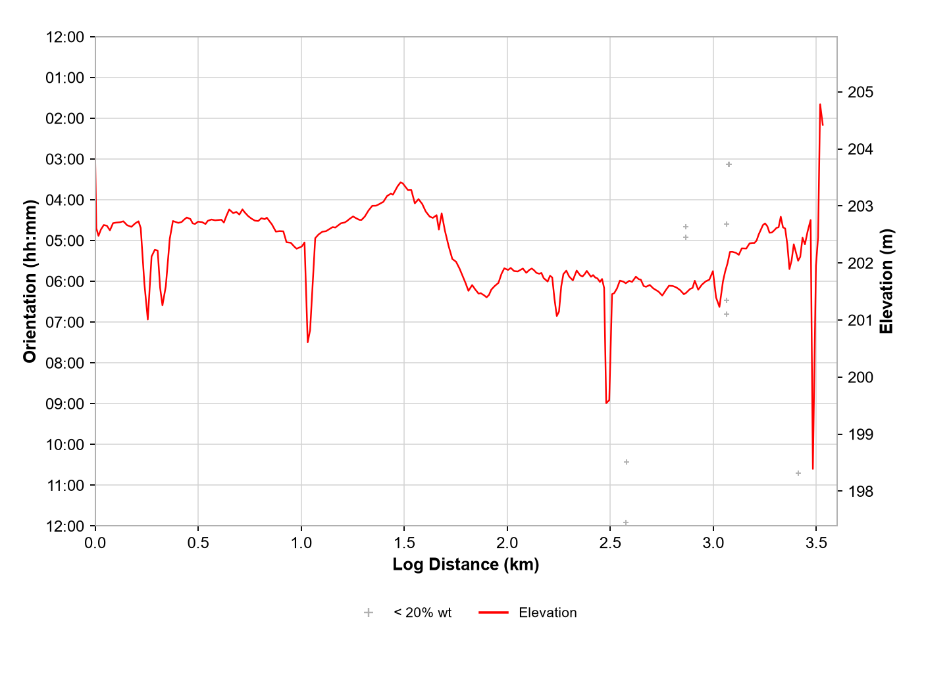
Figure 2: External Corrosion; Depth, Orientation & Elevation vs. Log Distance
Figure 2 shows the distribution of external corrosion anomalies with respect to log distance, orientation and pipeline elevation.

The external corrosion anomalies were included in the ILI comparison stage, discussed in Section ‎3.3, to review changes between inspections.

Non-Corrosion Metal Loss
The 2026 ILI reported 167 non-corrosion anomalies, comprising 125 pipe mill anomalies and 42 longitudinal weld anomalies. These counts include unsized indications.
- 116 pipe mill anomalies with metal loss and 9 unsized pipe mill indications. The maximum reported metal-loss depth was 19% wt at log distance 2,791.239 m.
- 28 longitudinal weld anomalies with metal loss and 14 unsized longitudinal weld indications. The maximum reported metal-loss depth was 29% wt at log distance 718.813 m.
The distributions of the reported non-corrosion metal loss anomalies are shown in the following sub-sections, with respect to depth, orientation and nominal wall thickness.

The non-corrosion metal loss anomalies detected by MFL-A were included in the ILI comparison stage, discussed in Section ‎3.4, to determine whether any change had occurred between ILIs.

Pipe Mill Anomalies
Figure 3 shows the distribution of the 116 sized pipe mill anomalies and 9 unsized indications along the length and around the circumference of the pipeline.

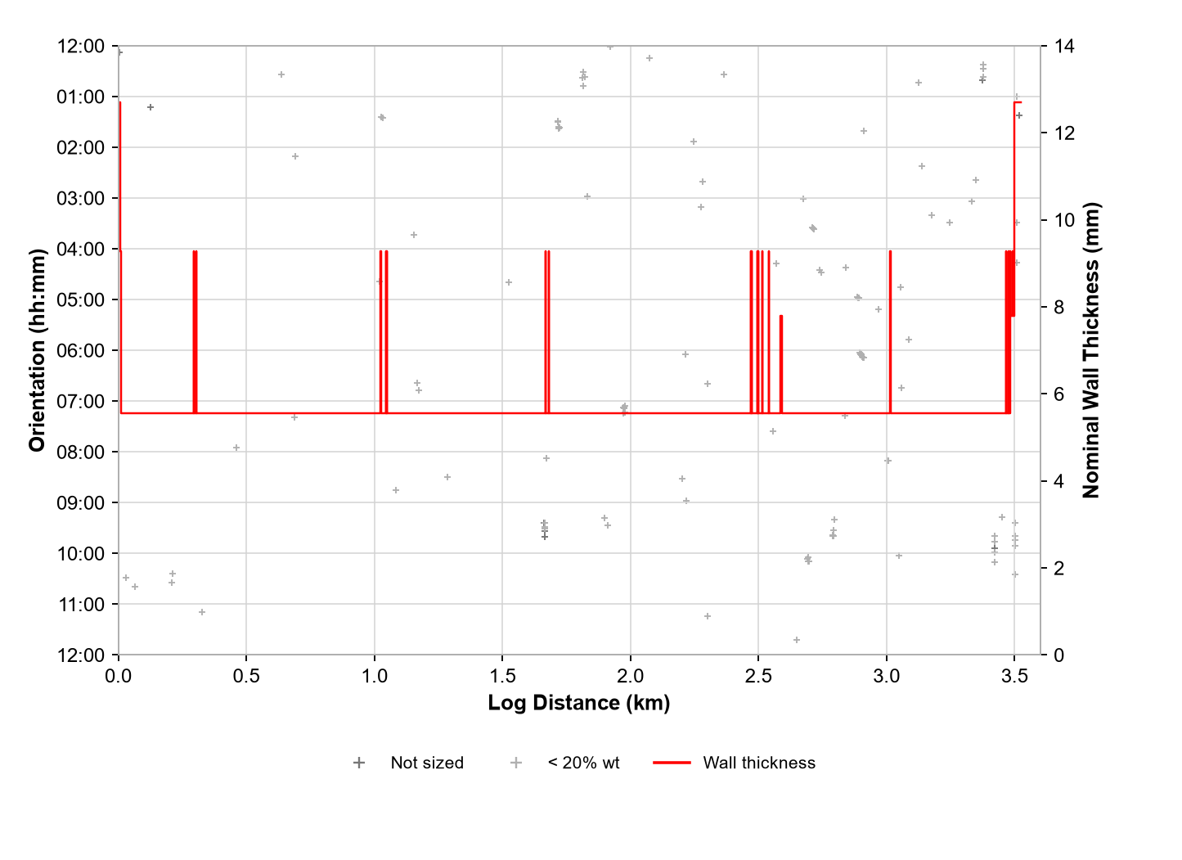
Figure 3: Manufacturing Anomalies; Depth, Orientation & Nominal Wall Thickness vs. Log Distance

Longitudinal Weld Anomalies
Figure 4 shows the distribution of the 28 sized longitudinal weld anomalies and 14 unsized indications along the length and around the circumference of the pipeline.

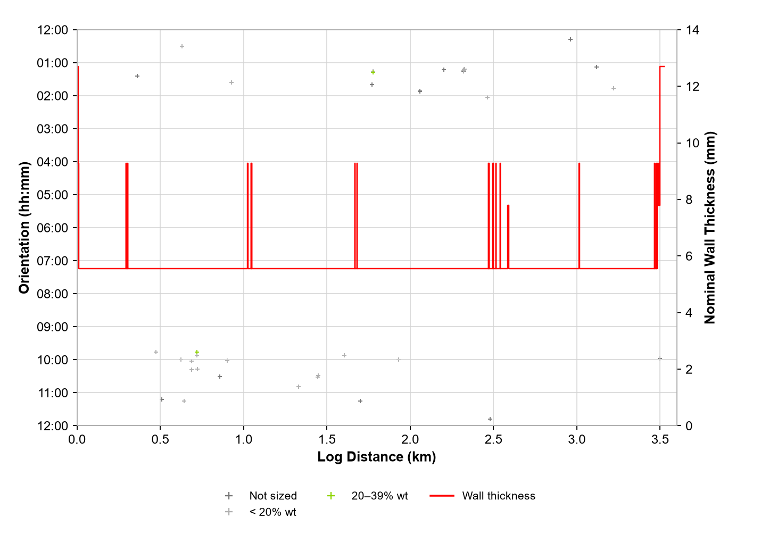
Figure 4: Seam Weld Anomalies; Depth, Orientation & Nominal Wall Thickness vs. Log Distance

Geometric Anomalies
The 2026 inspection reported 14 geometric anomalies, all classified as plain dents:
- 14 plain dents were reported. The maximum reported OD reduction was 1.4%, at log distance 218.019 m.
- No dents with metal loss were reported in the inspection summary.
- No dents with grooving were reported in the inspection summary.
- No wrinkles were reported in the inspection summary.
- No ovalities were reported in the inspection summary.
Figure 5 shows the distribution of reported geometric anomalies with respect to center orientation and elevation along the pipeline length. The 03:00 and 09:00 clock positions are shown for reference.

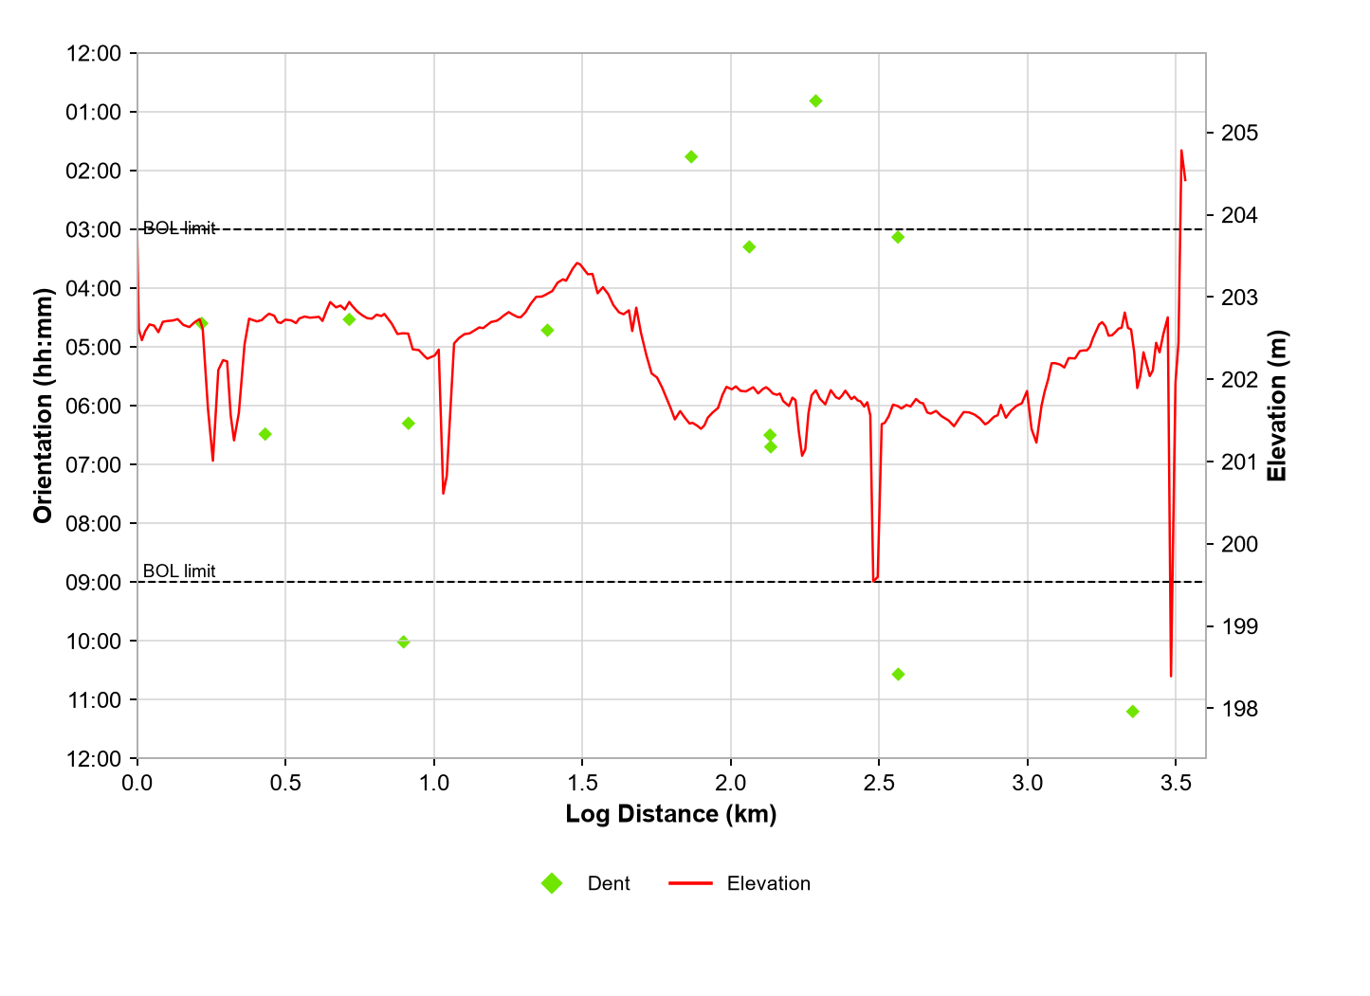
Figure 5: Geometric Anomalies; Center Orientation & Elevation vs. Log Distance

ILI Comparison

CGA^{pro} with AutoSCAN
The assessment methodology is referenced in the ROSEN Standard Methodology Document for Fitness for Purpose (FFP) and Corrosion Growth Assessment (CGA) Services [5].

The AutoSCAN comparison covers the 2016 and 2026 MFL-A/C ILIs. The recommended CGR rates apply to all corrosion anomalies reported by the 2026 ILI.

Internal Corrosion

ILI Comparison: AutoSCAN
The 2026 ROSEN ILI dataset contains 474 individual internal corrosion anomalies: 436 Matched, 27 New, 2 Matched (Reduced Accuracy), 6 Not Comparable and 3 with no corresponding MFL signal. CGRs were available for 465 anomalies, including all 436 Matched anomalies. The maximum matched CGR was 0.06 mm/year, and the maximum for the Reduced Accuracy anomalies was 0.13 mm/year.
Table 5: Summary of Internal Corrosion ILI Comparison Results
Result | Number of Anomalies | Maximum CGR
New | 27 | 0.19 mm/year
Matched | 436 | 0.06 mm/year
Matched (Reduced Accuracy) | 2 | 0.13 mm/year
Others | 9 | -
Total | 474 | -
Note The assessments consider all reported anomalies individually (boxes); therefore, the counts above reflect anomalies reported prior to the application of the anomaly interaction criteria which result in clusters. The Others category comprises 6 Not Comparable anomalies and 3 with no corresponding MFL signal; their CGRs are unavailable.

The maximum estimated Matched internal CGR, based on the AutoSCAN process, was 0.06 mm/year, associated with a 13% wt anomaly at log distance 3,516.823 m. A signal comparison for an 18% wt internal corrosion anomaly at log distance 3,518.862 m is presented below.
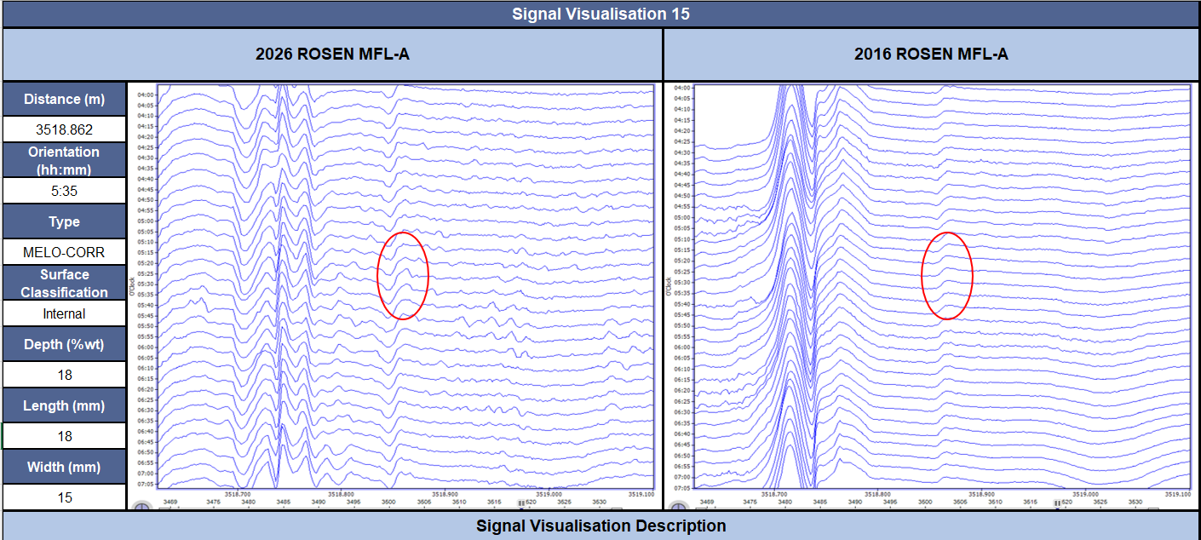
Figure 6: Signal Comparison; 18% wt internal corrosion anomaly at log distance 3,518.862 m.
A signal comparison was completed for the maximum-depth internal corrosion anomaly, reported at log distance 747.680 m with a depth of 32% wt and an estimated CGR of 0.01 mm/year. The signal comparison is presented below:
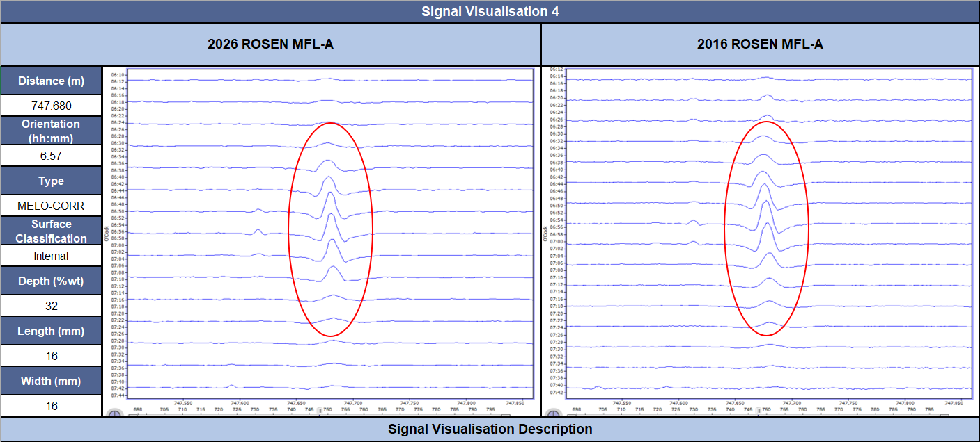
Figure 7: Signal Comparison; 32% wt internal corrosion anomaly at log distance 747.680 m.

Recommended Corrosion Growth Rates

Selection of Representative Anomalies
Only anomalies with CGRs considered representative of corrosion behavior over the ILI interval are included in the segmentation analysis. Six internal corrosion anomalies were classified as Not Comparable and excluded from the assessment. Three further anomalies had no corresponding MFL signal and no available CGR. The remaining 465 individual internal corrosion anomalies had numeric CGRs.

Segmentation Results
The segmentation followed the process detailed in Section 2.3 of the ROSEN Standard Methodology Document for Fitness for Purpose (FFP) and Corrosion Growth Assessment (CGA) Services [5]. Verification required: provide the cited methodology document.
Combination and rationalization of sub-segmentation results yielded one discrete CGR segment for use in future integrity management planning, which is considered to represent the variation in the internal corrosion susceptibility and activity observed throughout the pipeline. The results are shown in Figure 8 and Table 6.
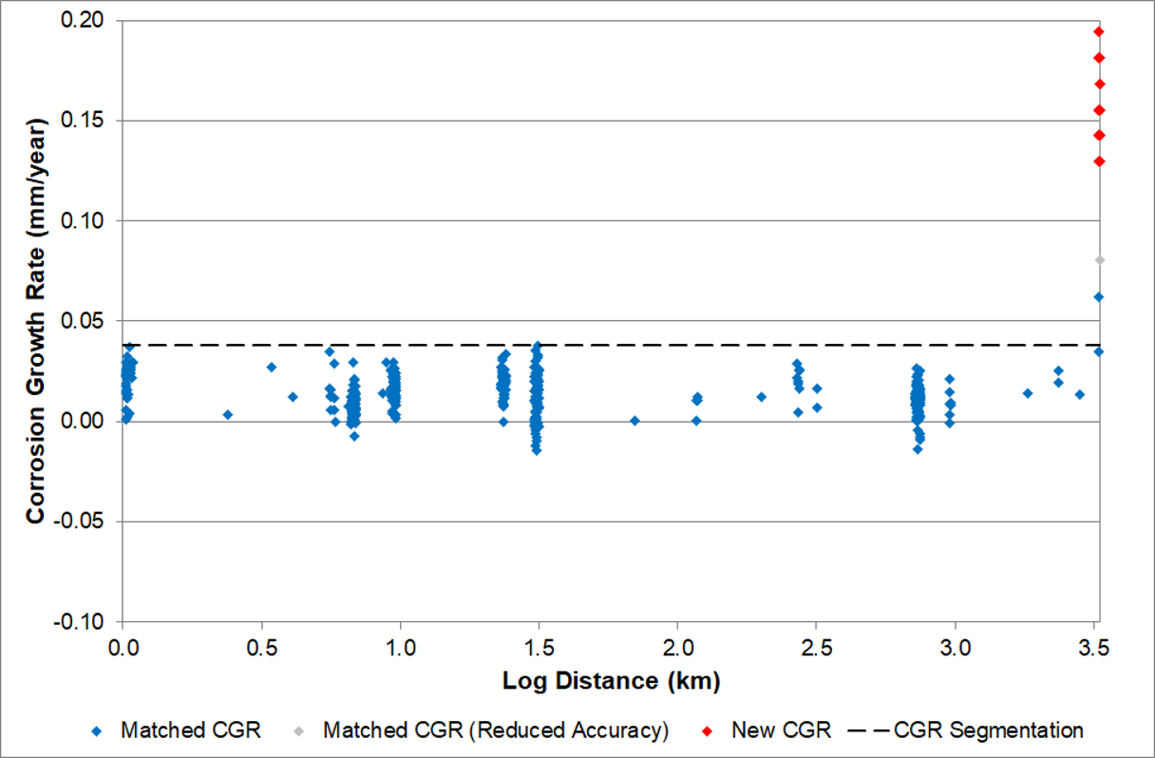
Figure 8: Internal Corrosion Segmentation; CGR vs. Log Distance
Table 6: Internal Corrosion Segmentation Results
Segment ID | Start Log Distance (m) | End Log Distance (m) | Recommended CGR (mm/year)
IC1 | Start of Line | End of Line | 0.04

External Corrosion

ILI Comparison: AutoSCAN
Table 7 shows a summary of the external corrosion ILI comparison results, with anomaly counts for each classification and maximum associated CGRs.
The 11 individual external corrosion anomalies comprise 10 Matched and 1 Matched (Reduced Accuracy).
Table 7: Summary of External Corrosion ILI Comparison Results
Result | Number of Anomalies | Maximum CGR
Matched | 11 | 0.04 mm/year
Total | 11
Note The assessments consider all reported anomalies individually (boxes); therefore, the counts above reflect anomalies reported prior to the application of the anomaly interaction criteria which result in clusters. The 11 anomalies comprise 10 Matched and 1 Matched (Reduced Accuracy).

The maximum estimated matched external CGR, based on the AutoSCAN results, was 0.04 mm/year, associated with a 16% wt anomaly reported at log distance 2,575.358 m. The corresponding 2026 and 2016 signal comparison is presented in Figure 9.
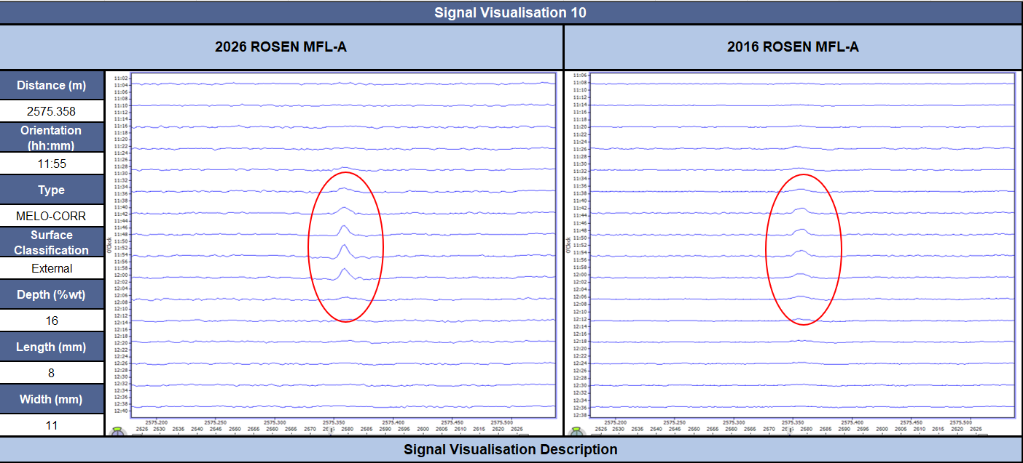
Figure 9: Signal Comparison; 16% wt External Corrosion Anomaly at Log Distance 2,575.358 m, CGR of 0.04 mm/year

Recommended Corrosion Growth Rates

Non-Corrosion Metal Loss

ILI Comparison: AutoSCAN
Table 8 shows a summary of the non-corrosion ILI comparison results, with anomaly counts for each classification and the maximum associated depth change. No unsized indications are listed in this comparison. Verification required: confirm the inclusion filter for the 96 comparison anomalies from the 167 reported non-corrosion anomalies.

91 individual non-corrosion anomalies were classified as Matched and 5 as Matched (Reduced Accuracy). The non-corrosion metal loss comparison results are summarized below:
Table 8: Summary of Non-Corrosion Metal Loss ILI Comparison Results
Result | Number of Anomalies | Maximum Depth Change
Matched | 91 | 5.9% wt
Matched (Reduced Accuracy) | 5 | 4.6% wt
Total | 96 | -

Three non-corrosion metal loss anomalies were included in the signal comparison. The signal of a manufacturing feature at log distance 718.813 m in the 2026 ILI was compared with the 2016 ILI signal. The comparison showed a depth change of 1.1% wt. The signal comparison of this anomaly is presented in Figure 10.

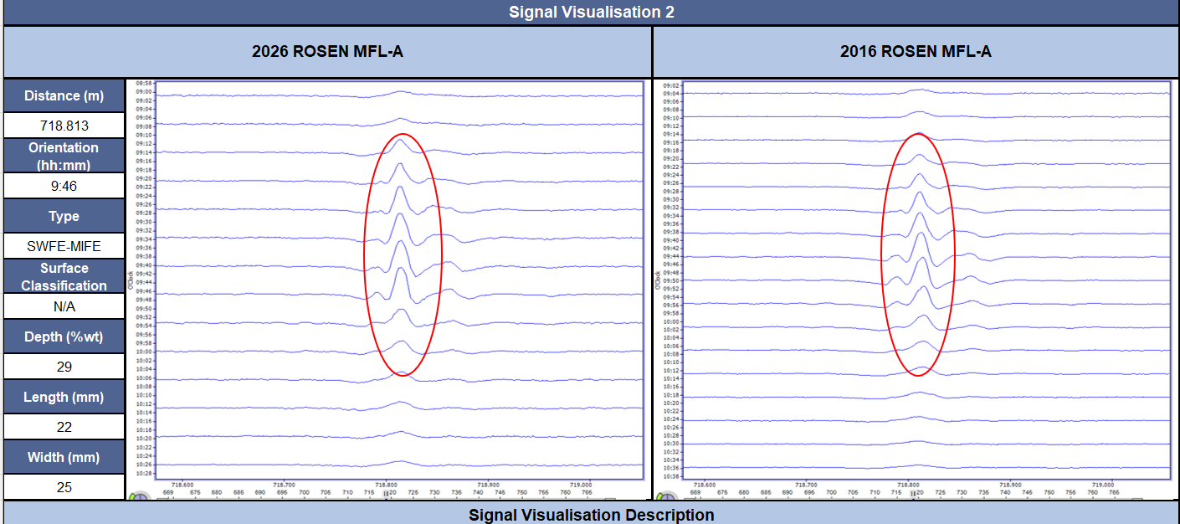
Figure 10: Signal Comparison; 29% wt Non-Corrosion Metal Loss Anomaly at Log Distance 718.813 m.

Geometric Anomalies
All 14 geometric anomalies reported by the 2026 ILI were included in the comparison using a box-matching process and signal review of selected anomalies. Four have previous-inspection entries and ten do not. The recorded box-matching results are summarized in Table 9.
Table 9: Comparison of Geometric Anomalies
Anomaly Type | Total Number of Anomalies | Number Matched to  Previous ILI | Number Not Matched to  Previous ILI
Dent | 14 | 4 | 10
Total | 14 | 4 | 10

All 10 unmatched deformations were reviewed in the 2016 ROSEN signal data and were found to show similar indications to those in the April 2026 ROSEN signal data, confirming they were present but not reported. Verification required: record the ten dent-review decisions in the supporting workbook.

References

[1] | Asset-specific scope quotation: not supplied for verification.
[2] | ROSEN, Inline Inspection Survey Report, RoCombo MFL-A/XT with Gyro and RoCorr MFL-C, NPS 10 No. 167 Pool, Project 0-1001-18081, July 7, 2026.
[3] | ROSEN, Inline Inspection Survey Report, RoCombo MFL-A/XT with Gyro and RoCorr MFL-C, NPS 10 167 Pool Pipeline, Project 0-1001-13454, October 14, 2016.
[4] | Asset-specific repair history: not supplied for verification.
[5] | ROSEN Standard Methodology Document FFP and CGA Services: referenced by the template; not supplied for verification.

LEGAL DISCLAIMER

ENGINEERING BASIS, RESPONSIBILITY, AND LIMITATIONS
This report has been prepared by ROSEN (“Company”) for the exclusive use of the Client for the specific purpose identified herein. The results and conclusions are intended to support engineering and integrity decision-making related to the assessed asset. This report shall not be used for any other purpose, nor relied upon by any third-party, without the prior written consent of the Company.

The engineering services documented in this report were performed using reasonable skill, care, and diligence consistent with generally accepted engineering practice and applicable industry standards and codes identified within this report. No warranty, express or implied, is made regarding the absolute accuracy or completeness of the results beyond this standard of care.

This assessment relies on information, data, and documentation provided by the Client and/or its representatives, including but not limited to inspection data, operating conditions, material properties, construction records, and historical information. The Company has not independently verified the accuracy or completeness of such information and is entitled to rely upon it as provided. Inaccurate, incomplete, or missing information may materially affect the results and conclusions of this report.

The analyses presented herein may incorporate the use of proprietary and/or third-party analytical tools, software, and calculation methodologies. While such tools are applied in accordance with accepted engineering practice, the Company makes no representation regarding the absence of errors or omissions in the underlying software code or numerical methods.

All engineering assessments, including but not limited to remaining life estimates, failure pressure calculations, fitness-for-service evaluations, and corrosion growth assessments, are based on stated assumptions and inherently involve uncertainty. These uncertainties arise from data quality, measurement tolerances, modeling limitations, future operating conditions, and variability in degradation mechanisms.

The conclusions and recommendations contained in this report are valid only for the operating conditions, assumptions, and data explicitly stated herein. Changes, including but not limited to operating pressure, temperature, product, loading conditions, environment, degradation rates, inspection technology, inspection quality, or damage mechanisms may invalidate the results and require reassessment.

This report provides engineering analysis and recommendations intended to support the Client’s integrity management and decision-making processes. Final responsibility for all decisions relating to operation, inspection, repair, mitigation, modification, reassessment frequency, and continued service of the asset remains solely with the Client and/or the owner-operator. Nothing in this report should be interpreted as directing or approving specific operational or repair actions.

This assessment does not replace or supersede the Client’s integrity management program, regulatory obligations, internal engineering judgment, or management of change requirements. The Client remains responsible for compliance with all applicable laws, regulations, codes, and standards in the jurisdictions where the asset is located.

To the extent permitted by applicable law, the Company’s liability arising from or related to this report shall be subject to the limitations set forth in the governing agreement between the Company and the Client.

In the absence of such an agreement, or where the governing agreement is silent on liability limitations, in no event shall the Company’s aggregate liability, for any reason and in connection with any claim asserted, exceed the amount paid by the Client for the services giving rise to the claim.

In no event shall the Company be liable for any indirect, incidental, consequential, special, or punitive damages, including but not limited to loss of use, production, revenue, or profit.

Nothing in this section is intended to exclude or limit liability that cannot be excluded or limited under applicable law.

This assessment does not constitute a guarantee or assurance of future asset performance, integrity, or remaining life. Asset behavior may differ from predicted outcomes due to factors outside the Company’s control.

This report is subject to the terms and conditions of the governing agreement between the Company and the Client.
- Scope of Work
The scope of work is to perform a CGA based upon the findings of the 2026 and 2016 ILIs [1]. The assessment methodologies used are outlined in the ROSEN Standard Methodology Document for Fitness for Purpose (FFP) and Corrosion Growth Assessment (CGA) Services [5].
- Review the ILI data and provide a breakdown of the main anomalies relevant to the study (anomaly distribution, changes in pipe characteristics, repairs / replacements, etc.).
- Provide a depth difference for all MFL-A/C reported metal loss anomalies based on a signal level comparison (using AutoSCAN).
- Provide images of the signal comparison for up to 30 anomalies. This will include the deepest anomalies, those with the greatest depth difference, new anomalies and those in corrosion hotspots.
- Split the pipeline into segments using a semi‑automated segmentation process (note, a unique segmentation will be produced for internal and external corrosion as applicable).
- Recommend a characteristic corrosion growth rate (CGR) to be assigned to the corrosion anomalies in each defined segment.
- Identify any other changes in the pipeline, e.g. dents introduced between the two ILI runs. This is limited to identifying new geometric anomalies and does not aim to identify/rule out any change in deformation shape.
- Document the findings in a written report and spreadsheet listing.

Segmentation Results
The segmentation followed the process detailed in Section 2.3 of the ROSEN Standard Methodology Document for Fitness for Purpose (FFP) and Corrosion Growth Assessment (CGA) Services [5].
Combination and rationalization of sub-segmentation results yielded one discrete CGR segment for use in future integrity management planning, which is considered to represent the variation in the external corrosion susceptibility and activity observed throughout the pipeline. The results are shown in Figure 11 and Table 10. Verification required: confirm this section’s placement and its table-of-contents entry.
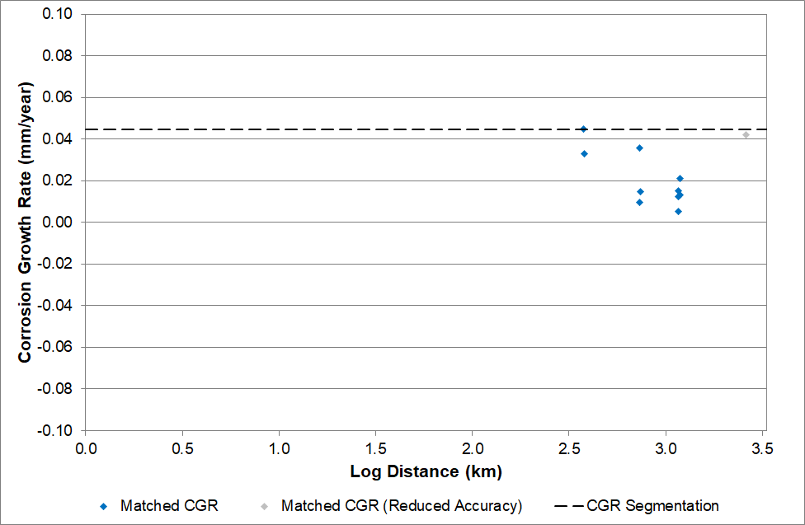
Figure 11: External Corrosion Segmentation; CGR vs. Log Distance
Table 10: External Corrosion Segmentation Results
Segment ID | Start Log Distance (m) | End Log Distance (m) | Recommended CGR (mm/year)
EC1 | Start of Line | End of Line | 0.04

- Signal Comparisons

A statistical growth threshold and its validation were not supplied; no confidence-level conclusion is independently established.
XT is ROSEN’s high resolution geometry inspection tool.
Anomalies further identified as in pipe body or interacting with weld in the ILI listing.
OD – outer diameter.
No dents with associated metal loss are reported in the current inspection summary.
Asset-specific composite-wrap and repair history was not supplied.
The ‘Other’ classification may include, but is not limited to, reduced accuracy anomalies (e.g. due to data issues, etc.), unlinked anomalies that were not manually reviewed, etc.
Unmatched is the literal authoritative alignment label. It is not independently interpreted as new, repaired or static.

